ICOM IC-706MKIIG Tech Notes
Loss of “HV” voltage:
If your IC-706MKIIG will not power up (and you’ve ruled out the DC cable and power supply), check the state of the “HV” line. Sometimes, surface-mount resistor R591 (under the PA Unit) will open, due to a power supply surge. And I have seen quite a few rigs where the rubber pad under the PLL Unit caused corrosion of the “HV” trace. Apparently, some kind of chemical reaction is taking place with the self-adhesive film between the rubber pad and the circuit board. Maybe it only happens in humid or damp environments. I’m not sure. But I’ve seen this happen to quite a few MKIIG’s.
Here is an example of the affected area, with the pad still in place: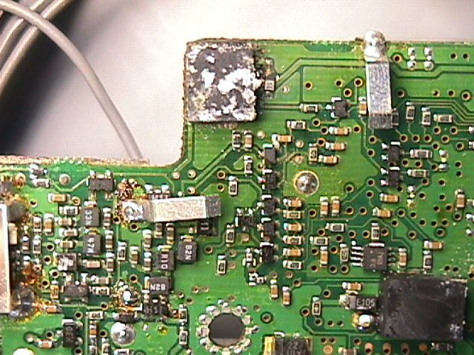
Here is an example of the affected area, with the pad removed: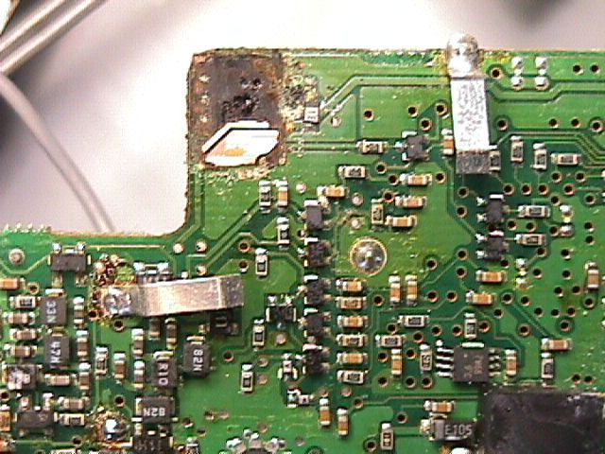
Here is an example of the affected area, bypassed with a jumper wire:
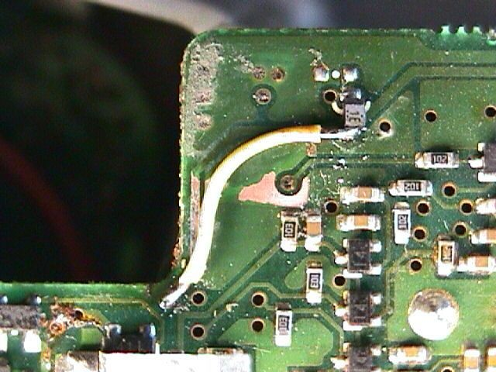
Unstable VCO or PLL Unlock:
Another common problem is VCO instability or PLL unlock. The symptoms can be intermittent distorted or garbled audio, affecting receive and transmit, or complete loss of RX/TX. The MKIIG has four VCO circuits, each one has a trimmer capacitor. Often, these trimmer caps will become unstable. Sometimes, giving the offending trimmer a few twists, then realigning to specs, will resolve the issue (at least temporarily). But replacing the trimmer is often required. And then, it is best to replace all four of them. It’s not an easy job, since they are surface-mount types, located inside cramped metal shields.
- The reference VCO affects all bands. Its trim-cap is C4 on the PLL Unit.
- VCO1 affects 0.03 to 29.999 MHz and 60.0 to 128.999 MHz. Its trim-cap is C306 on the PLL Unit.
- VCO2 affects 30.0 to 59.999 MHz and 129.0 to 199.999 MHz. Its trim-cap is C335 on the PLL Unit.
- VCO3 affects 400 to 470 MHz. Its trim cap is C367 on the PLL Unit.
To replace trimmer C4, shields MP5 and MP7 can be temporarily removed. To replace the other 3 trimmers, coils L302 and L332 can be temporarily removed, since removal of shield MP12 is much more difficult.
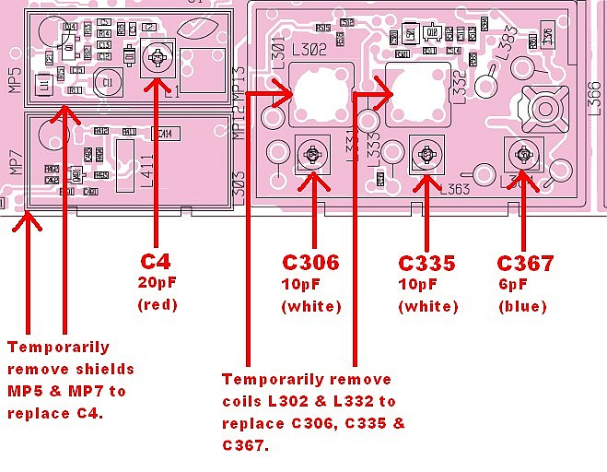
Varying TX output from band to band (HF and 6M only):
If your MKIIG has vastly varying transmitter output from band to band (into a dummy load), suspect surface-mount diode D9 and/or D10 on the Filter Unit. Usually, D9 is the only one at fault. These diodes are in the SWR-sensing circuit. They’re accessible without removing the filter board.
D9 and D10 are shown in the top-right corner:
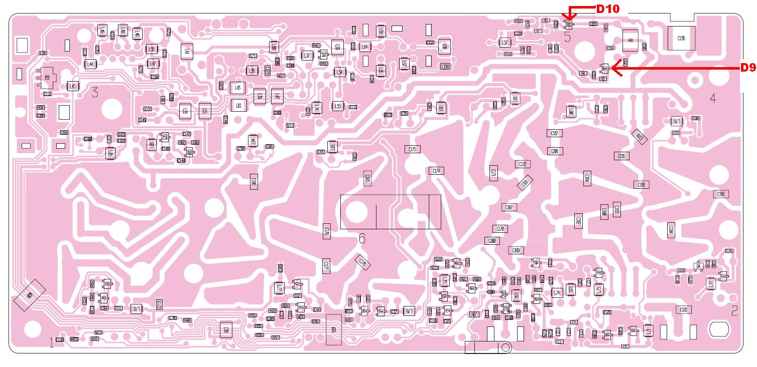
NOTE: If you don’t have the skills or equipment to work with static-sensitive surface-mount components, please leave it to an experienced technician.

